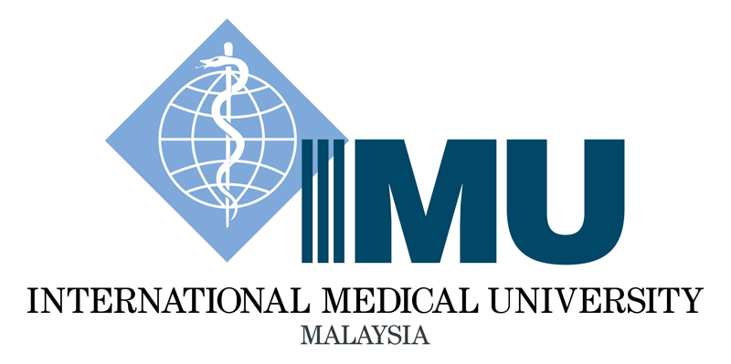

Msc Molecular Medicine

MM302

Immunology and Infection

(2 Credits)

Semester 1

Module Guide

TITLE: Immunology and Infection COURSE CODE: MM302

SEMESTER 1

PROGRAMME: Msc Molecular Medicine

CONTENT SYNOPSIS:

The aim of this course is to build an understanding and appreciation of the complex nature of immune system interactions with infectious microorganisms. In order to do this, a strong grasp of immunology and microbiology is required. This is an advance course that explores the immune responses as it deals with the arsenal of opportunistic microflora and pathogens that attack the human body. The various ways and means that microorganism deploy to cause disease (pathogenesis) is looked at. It covers the mechanism of subversion that microorganism employ to evade the immune system, and what happens when the immune response goes wrong. The methods of immunological and molecular detection of infectious disease are also covered. Finally, it will encompass how we can harness the power of the immune response for treatment and prevention of disease, and also novel technologies to study immune responses to microorganisms.
Students are expected to have a prior knowledge in Immunology and Microbiology. The guided reading is merely to help students revise and refresh themselves on immunology and infectious disease concepts before the commencement of this module. Students should have a firm grasp and knowledge of the innate and adaptive immunity, interactions between acquired and innate immunity, the complement system, immunoglobulins, T-cells, B-cells, cytokines, immune response to infectious disease and vaccines.

AIMS
The aim of this course is to build an understanding and appreciation of the complex nature of immune system interactions with infectious microorganisms.

OBJECTIVES:

The objectives of this module are to:

- describe how the immune system functions to defend the host against infections by microbes.
- discriminate the interaction between the immune system, normal microbial flora and pathogens.
- assess the factors involved in pathogenesis and microbial subversion of host immune defences.
- outline the current laboratory diagnostic methods to detect infections.
- evaluate current and new strategies in immune therapeutics and vaccine generation.
- develop the ability to effectively communicate and work with peers and teachers through discussions.
- generate critical thinking and information management through discussions and evaluation of scientific literature.

LEARNING OUTCOMES:

At the end of this course, the student should be able to:
- Define and relate the factors involved in host-pathogen interactions.
- evaluate clinical laboratory immunological analyses of important infections.
- compare and analyse strategies in immune therapeutics and vaccine development.
- display effective communication and presentation skills, teamwork and professionalism.
- demonstrate competencies in information management, critiquing, analysing scientific literature and ethics.

LEARNING HOURS:

Total Student Learning Time (SLT) | Activity
Total Student Learning Time (SLT) | Face to Face | Independent Learning Hour
Lecture | 14 | 28
Written assignment (review article) |  | 28
Seminar | 2 | 8
Total Learning Hours | 80

ASSESSMENTS:
Coursework
Written assignment (review article) 60%
Seminar 40%

Students can select any one of the two seminar topics to present
MODULE COORDINATOR: Dr. Ho Ket Li
ASSOCIATED LECTURERS: Prof. Dr. Victor Lim, Dr. Kenny Voon Gah Leong, Dr. Amalraj Fabian Davamani, Dr. Liew Yun Khoon, Dr. Ho Ket Li

SYLLABUS:

1. Immunology and immunotherapy (Lectures – 2 hrs)
Immunology is found to be associated with both communicable and non-communicable diseases such as cancer and diabetes. The learning issues will include the roles of immunology in communicable diseases and immunotherapy as a new viable treatment option.

2. Bacterial pathogenesis (Lectures – 2 hrs)
A recent example of the latest emerging/re-emerging bacterial pathogen is used as a model for discussion on bacterial pathogenesis e.g. Mycobacterium tuberculosis. The learning issues will include multidrug resistance (MDR), environmental microbiome, host defences and microbial subversion mechanisms.

3. Viral pathogenesis (Lectures – 2 hrs)
A recent example of the latest emerging/re-emerging viral pathogen is used as a model for discussion on viral pathogenesis e.g. COVID19 etc. The learning issues will include innate immune control of viral infection, acquired immune control of viral infection, effects of viral replication on host cells, and viral evasion of host immune mechanisms.

4. Fungal pathogenesis (Lectures – 2 hrs)
A recent example of the latest emerging/re-emerging fungal pathogen is used as a model for discussion on fungal pathogenesis. The learning issues will include superficial and systemic fungal infection, host defences and microbial subversion.

5. Parasitic pathogenesis (Lectures – 2 hrs)
A recent example of the latest emerging/re-emerging parasitic pathogen is used as a model for discussion on parasite pathogenesis. The learning issues will include probiotics versus helminth in human, host defences and microbial subversion mechanisms.

6. Antimicrobials (Lectures – 2 hrs)
An update in antimicrobial resistance threats will be discussed. Students are expected to acquire knowledge in latest trends in antibacterial peptides and non-peptide mimetics, antibacterial peptide induction in tissues, DNA vaccines and other infectious disease therapies and strategies. Besides, behavioural change in combating antimicrobial resistance will also be included.

7. Vaccines (Lectures – 2 hrs)

Students are expected to acquire knowledge in various types of vaccines and their production. Besides the adverse effects of vaccines will also be discussed.

8. Seminar (Seminar Preparation- 8 hrs, Seminar – 2 hrs, assessment: 40%): Choose of the two topics
a. Immunological Detection of Infectious Diseases
Current diagnostic methods for specific infections may have been briefly discussed in Part 2. However students will need to research in depth the broader spectrum of techniques (immunological & molecular) employed in detection of infectious diseases and factors that influence immunological testing results with regards to current practices and future trends.

b. Vaccines
Students are expected to present the issues and latest development in vaccinology or immunotherapeutics in infectious diseases especially in the verification of vaccination response and vaccine development (field results interpretation with a model vaccine trial). They are expected to use online resources such as WHO, CDC, NIH, Vaccine therapeutics journal, http://f1000biology.com, http://www.the-scientist.com, nature.com and journals.

9.Infection and Immunity: Recent trend (28 hrs)
Students will need to choose a topic on infection and immunity and prepare the written assignment in a review article format. The topic chosen need to be approved by the module coordinator. Students need to choose a journal that they wish to publish and the format will be as specified by the target journal. Students will be given 3 months to complete the article and another 3 months for resubmission.

READING LIST:

- Abbas AK, Lichtman AH, Pillai S. Basic immunology e-book: functions and disorders of the immune system. Elsevier Health Sciences; 2019 Jan 25.
- Spickett G. Oxford handbook of clinical immunology and allergy. Oxford University Press, USA; 2019 Jul 29.
- Nature Immunology. 21(7): 697-697; Nature publishing Group, Springer Nature Journals.

